| **Test Name** | | | Submit new question | | | |
| --- | --- | --- | --- | --- | --- | --- |
| **Use Case Tested:** | | | Submit Question-Check Editable Fields | | | |
| **Test Description:** | | | Check that fields are editable | | | |
| **Pre-conditions** | | | User must of logged in  Submit question scene should be open | | | |
| **Post-conditions** | | | That all input fields can be edited | | | |
| **Notes:** | |  | | | | |
| **Result (Pass/Fail/Warning/Incomplete)** | |  | | | | |
|  | **TEST STEP** | | | **EXPECTED TEST RESULTS** | P | F |
|  | User writes in question field | | | Field should be editable |  |  |
|  | User writes in all answer fields | | | Fields should be editable |  |  |
|  | User chooses category | | | Drop box should allow choosing of a category |  |  |

|  |  |  |  |  |  |
| --- | --- | --- | --- | --- | --- |
| **Test Data Table** | | | | | |
|  | **Correct Answer** | **Wrong Answer1** | **Wrong Answer2** | **Wrong Answer3** | **5** |
| In the first film, the clocks in Doc's garage all chime at 8am. But what is the real time? | 8.25 | 8.10 | 8.45 | 8.00 |  |

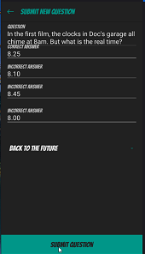

Submit question page with all input boxes filled

| **Test Name** | | | Submit new question | | | |
| --- | --- | --- | --- | --- | --- | --- |
| **Use Case Tested:** | | | Submit question | | | |
| **Test Description:** | | | Check that submit button adds new question to database | | | |
| **Pre-conditions** | | | User must have logged in  Submit question scene should be open | | | |
| **Post-conditions** | | | Question should be added to the question database | | | |
| **Notes:** | | **All worked with the exception of adding to the database- question not added** | | | | |
| **Result (Pass/Fail/Warning/Incomplete)** | | **Failed First run** | | | | |
|  | **TEST STEP** | | | **EXPECTED TEST RESULTS** | P | F |
| 1. | Enter question | | | Question will be entered | P |  |
| 2. | Enter four answers | | | Four answers will be entered | P |  |
| 3. | Hit submit question button | | | Details should be sent to server and added to the question pool/answer pool and message saying attempting to submit question should display |  | F |
| 1. | Enter question | | | Question will be entered |  |  |
| 2. | Enter four answers | | | Four answers will be entered |  |  |
| 3. | Hit submit question button | | | Details should be sent to server and added to the question pool/answer pool and message saying attempting to submit question should display |  |  |

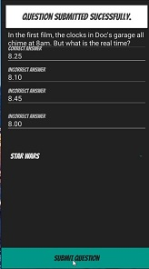

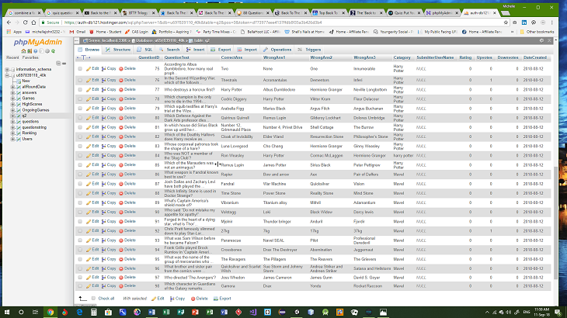

Question input submit question

pressed and correct message displayed Question added to database QuestionId did not add to database

Question input submit question

pressed and correct message displayed Question added to database QuestionId did not add to database

| **Test Name** | | | Submit new question | | | |
| --- | --- | --- | --- | --- | --- | --- |
| **Use Case Tested:** | | | Submit Question-Check Errors Display | | | |
| **Test Description:** | | | Check to see that error message displays when question and answer fields are blank | | | |
| **Pre-conditions** | | | User must have logged in  Submit question scene should be open | | | |
| **Post-conditions** | | | Error message should be displayed | | | |
| **Notes:** | |  | | | | |
| **Result (Pass/Fail/Warning/Incomplete)** | | **Pass** | | | | |
|  | **TEST STEP** | | | **EXPECTED TEST RESULTS** | P | F |
| 1. | Leave question field blank while other fields filled in | | | Error message question cannot be empty is displayed | P |  |
| 2 | Leave correct answer blank while other fields filled in | | | Error message correct answer cannot be empty is displayed | P |  |
| 3 | Leave 1st wrong answer blank while other fields filled in | | | Error message wrong answer 1 cannot be empty is displayed | P |  |
| 4 | Leave 2nd wrong answer blank while other fields filled in | | | Error message wrong answer 2 cannot be empty is displayed | P |  |
| 5 | Leave 3rd wrong answer blank while other fields filled in | | | Error message wrong answer 3 cannot be empty is displayed | P |  |

|  |  |  |  |  |  |
| --- | --- | --- | --- | --- | --- |
| **Test Data Table** | | | | | |
|  | **1** | **2** | **3** | **4** | **5** |
| Empty | 8.25 | 8.10 | 8.45 | 8.00 |  |
| In the first film, the clocks in Doc's garage all chime at 8am. But what is the real time? | Empty | 8.10 | 8.45 | 8.00 |  |
| In the first film, the clocks in Doc's garage all chime at 8am. But what is the real time? | 8.25 | Empty | 8.45 | 8.00 |  |
| In the first film, the clocks in Doc's garage all chime at 8am. But what is the real time? | 8.25 | 8.10 | Empty | 8.00 |  |
| In the first film, the clocks in Doc's garage all chime at 8am. But what is the real time? | 8.25 | 8.10 | 8.45 | Empty |  |

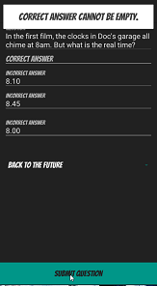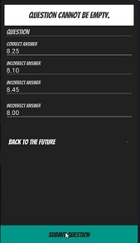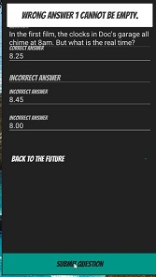

Question empty error displayed Correct answer blank error displayed Wrong answer 1 blank error displayed

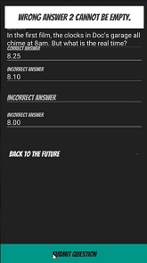

Wrong answer 2 blank error displayed Wrong answer 3 blank error displayed

